Information Protected. Personal information provided in this form is protected, and used in accordance with the Data Protection Act

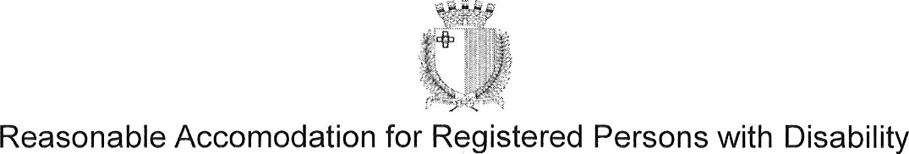

The following information should be submitted by an applicant registered with Aġenzija Sapport who is requesting reasonable accommodation during the selection process for a post or position in the Public Service of Malta. Such personal data is processed by the Public Service Commission in order to consider this application.
Surname:
Date of birth:

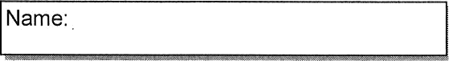

Identity Card Number
Title of advertised vacancy:

Date of Call: | Circular No. (if applicable):
EU Disability Card No. issued by Aġenzija Sapport (attach photocopy):
Issued
Short description of disability:
The specific eligibility requirements/s (possession of a qualification, years of experience etc.) in the relevant call for applications with respect to which an exemption is being requested.

Justification as to how your disability has impeded you from satisfying eligibility criteria mentioned in the relative call:
I am attaching copy of a medical certificate confirming my disability. (Medical certificate can be up to two years old or even older if disability is of a permanent nature).
I declare that to the best of my knowledge, all information given on this form is correct, and I am aware that any proved false statement or declaration given by me on this form can lead to the termination of this appointment, if given. I am also giving my consent to the Selection Board to check any statement or information given on this form with Aġenzija Sapport.

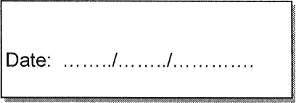

Signature:

The information on this form will be sent by the Selection Board to the Public Service Commission (PSC) for processing purposes. The employing department/directorate, Aġenzija Sapport and the People & Standards Division (P&SD) can also have access to this form. Once PSC have taken their decision regarding the eligibility of the respective applicant a record of the decision taken will be retained in the relevant PSC file, and this form, together with any supporting documentation, will be destroyed

Procedure to be followed when reasonable accommodation for persons with disability is required (Section 2.3 of the Manual on Resourcing Policies and Procedures):

When reasonable accommodation by a person with disability is required in connection with an application for a post or position within the Public Service, the form reproduced overleaf needs invariably to be filled, and signed by the person requesting such accommodation. This form is to be submitted by the applicant attached to his/her application form for the post, together with the required documentation, which should include:

a copy of the EU Disability Card issued by Aġenzija Sapport; and

- a copy of a medical certificate from a specialist medical practitioner attesting his/her disability. This certificate can be up to two years old, or even older if the disability of the applicant is of a permanent nature.
The Selection Board, which would have been appointed to evaluate such applications, will, in turn, submit this form, together with all supporting documentation, to the PSC without retaining a copy. The relative application form for the post/position applied for is to be retained by the Selection Board.
The PSC will decide on the merits of the applicant’s request for a waiver of one or more eligibility requirements, and issue instructions to the Selection Board accordingly, either to waive the eligibility requirement/s or not. PSC may also need to consult with the Head of Department (who had issued the relative call for applications) as to whether it is feasible to waive an eligibility requirement if that requirement appears to be a core requirement for the post applied for.

Once PSC has taken its decision, an extract of which will be entered into the relevant PSC file, this reasonable accommodation form, together with all relevant documentation, will be destroyed.

